**A Visual Book Summary of Atomic Habits by James Clear**

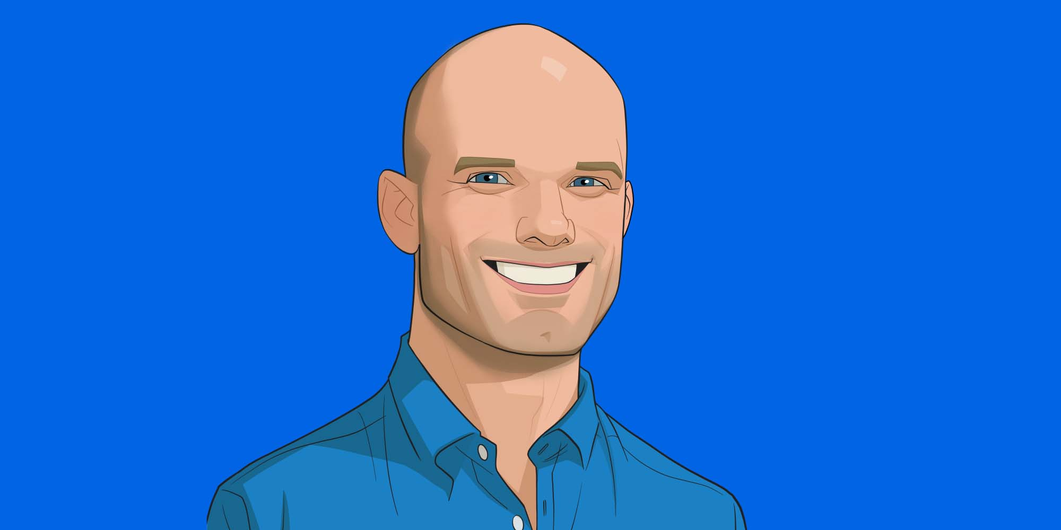

**What is *Atomic Habits* about?**

*Atomic Habits* explains how small, repeated actions (habits) compound to change your life. In this visual book summary we'll cover:

* [5 big ideas](https://www.thunknotes.com/blog/a-visual-book-summary-of-atomic-habits-by-james-clear#the-5-big-ideas) that will help you hit your goals and change your life[‍](https://www.thunknotes.com/blog/a-visual-book-summary-of-atomic-habits-by-james-clear#practical-tips-you-can-use-to-change-your-habits)
* [4 practical tips](https://www.thunknotes.com/blog/a-visual-book-summary-of-atomic-habits-by-james-clear#4-practical-tips-you-can-use-to-create-change) you can use to change your habits[‍](https://www.thunknotes.com/blog/a-visual-book-summary-of-atomic-habits-by-james-clear#how-im-personally-implementing-what-inbsplearned-from-the-book)
* [6 ways](https://www.thunknotes.com/blog/a-visual-book-summary-of-atomic-habits-by-james-clear#6-ways-im-personally-implementing-what-inbsplearned-from-the-book)I'm personally implementing what I learned from the book

‍

**The FREE Habit Worksheet**

I put together this free worksheet to help you change your habits. Click on the image below to get it:

‍

**The 5 Big Ideas**

‍

**1. Small repeated habits add up to big changes.**

Imagine you’re a pilot flying from Los Angeles to New York City. Just before takeoff you turn right by 3.5 degrees. This tiny change is barely noticeable on the runway. The front of the plane moves only 90 inches. It seems like nothing.

But when you take flight, that small change in direction starts to add up. After flying across the entire United States, you land hundreds of miles away in Washington DC instead of New York City.

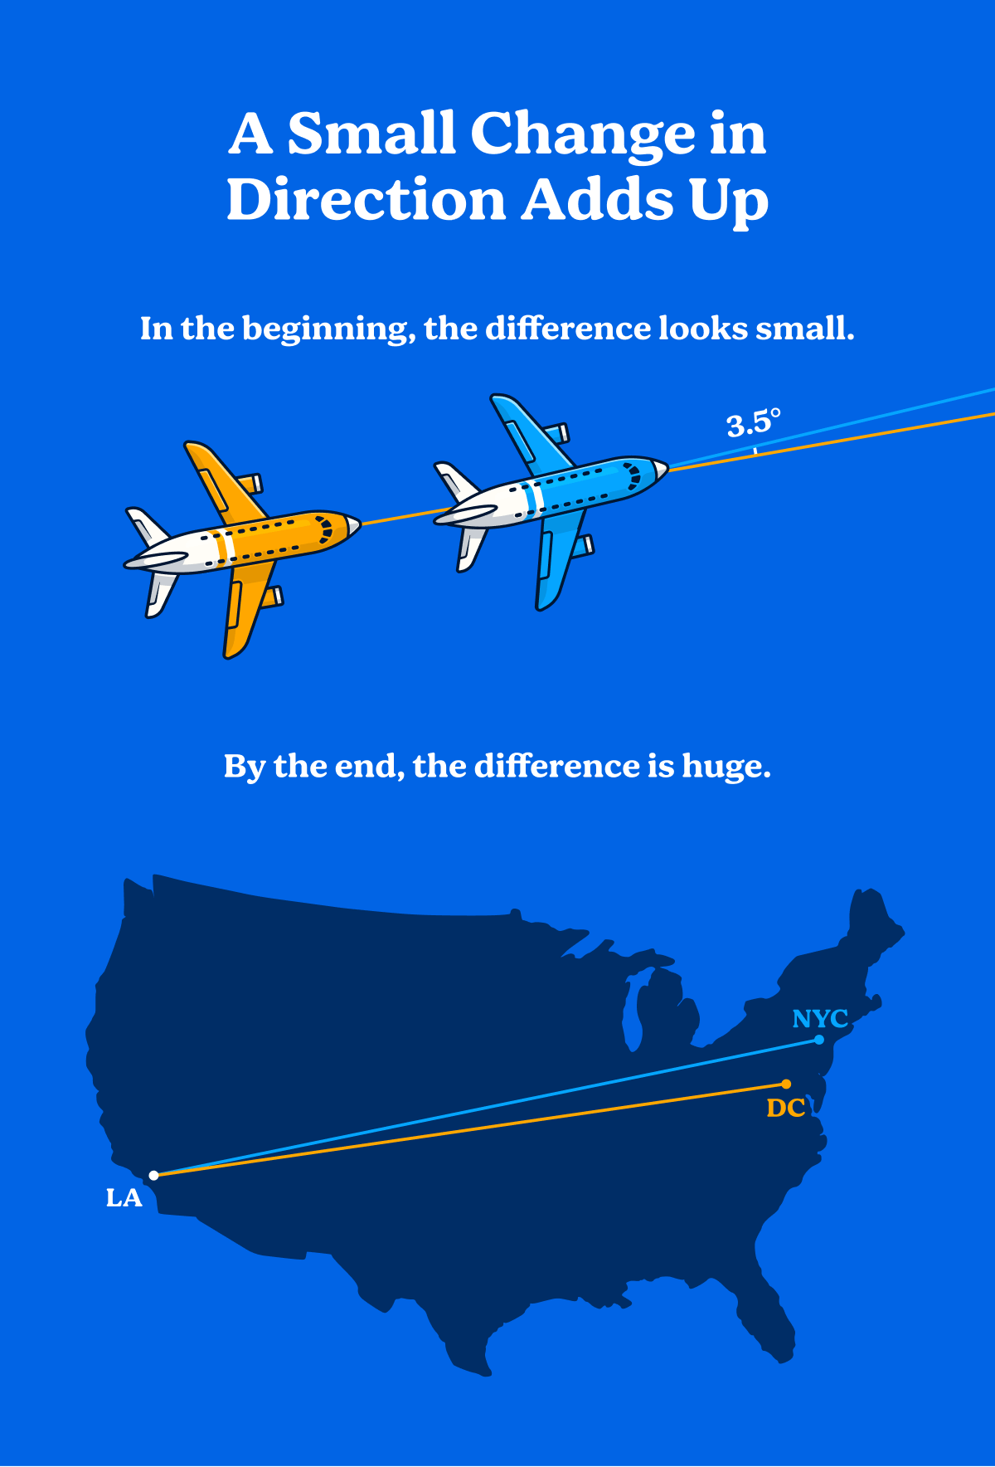

A small change in direction adds up

‍

Tiny changes in your habits add up in the same way. At the start you can’t see their impact. Over months and years, though, your habits multiply to change your life.

‍

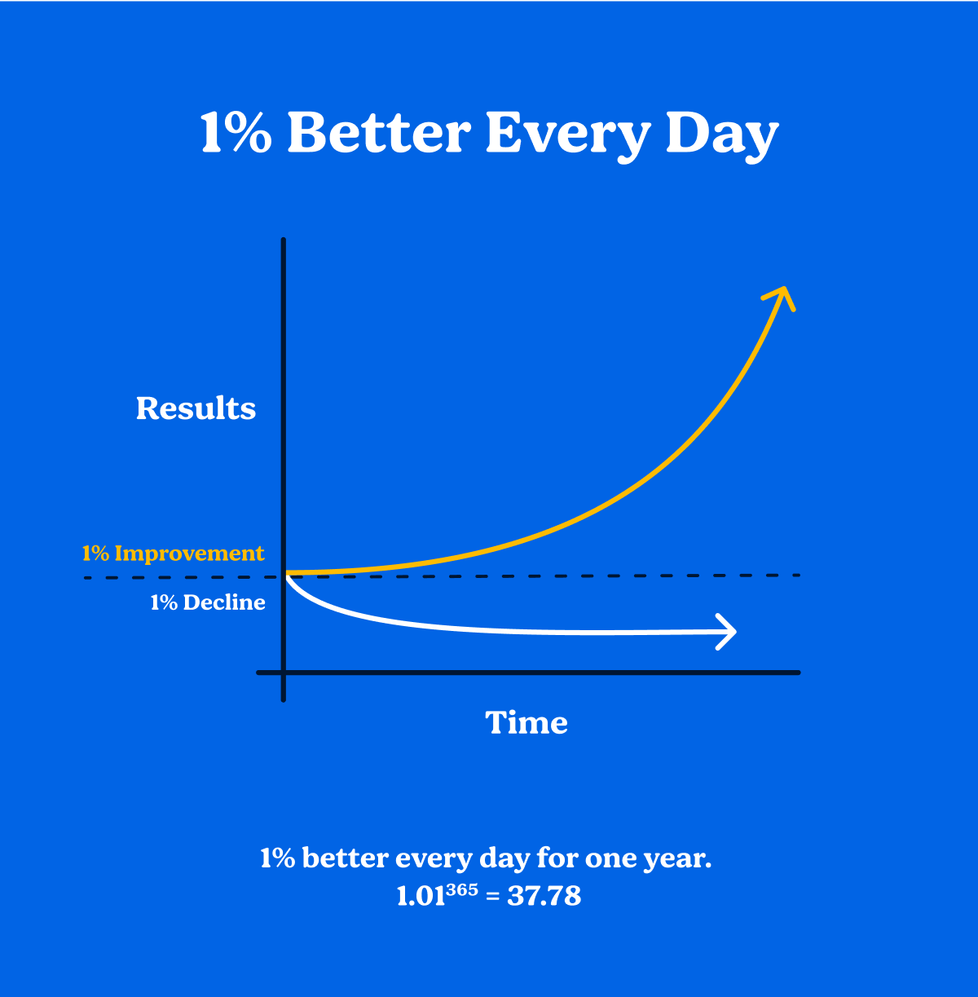

Small improvements compound over time

‍

“Habits are the compound interest of self-improvement.”  
*page 16*

‍

**2. Early progress is invisible. Don't get discouraged.**

Most of us want fast results—We want to see the impact of a new habit right away. Unfortunately, early progress is hidden.

Imagine an ice cube in a room 10 degrees colder than the melting point of ice. You heat up the room by 1 degree and look at the ice cube. Nothing's changed. You heat the room again—2 degrees. Still nothing. 3 degrees, 4 degrees—nothing. At this point you probably feel like giving up. The work you're doing to heat the room seems pointless.

But if you keep going, you'll eventually hit the melting point. Suddenly you get results—water starts dripping from the ice. With each additional degree, your work compounds. The ice melts faster and faster. All that invisible work is finally paying off.

‍

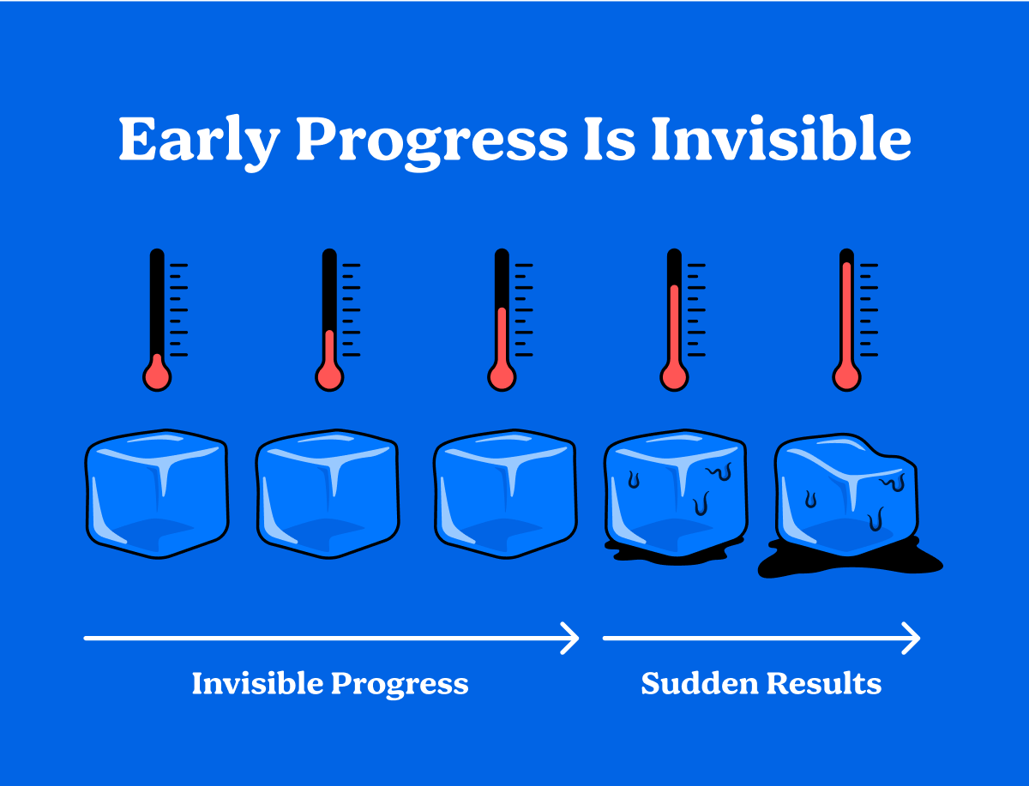

Early progress is invisible

‍

Habits work the same way. When you start a new habit you don't see immediate results. You might work for days, months, or even years. This long period of work with no results is discouraging—It's why a lot of people give up before they see a difference.

If you stick to a habit for long enough, eventually you'll break through **The Plateau of Latent Potential**. It’s the critical threshold (like hitting the melting point) where results become suddenly visible.

To the outside world, this looks like an overnight success, but you know the truth. Your sustained effort is finally visible.

‍

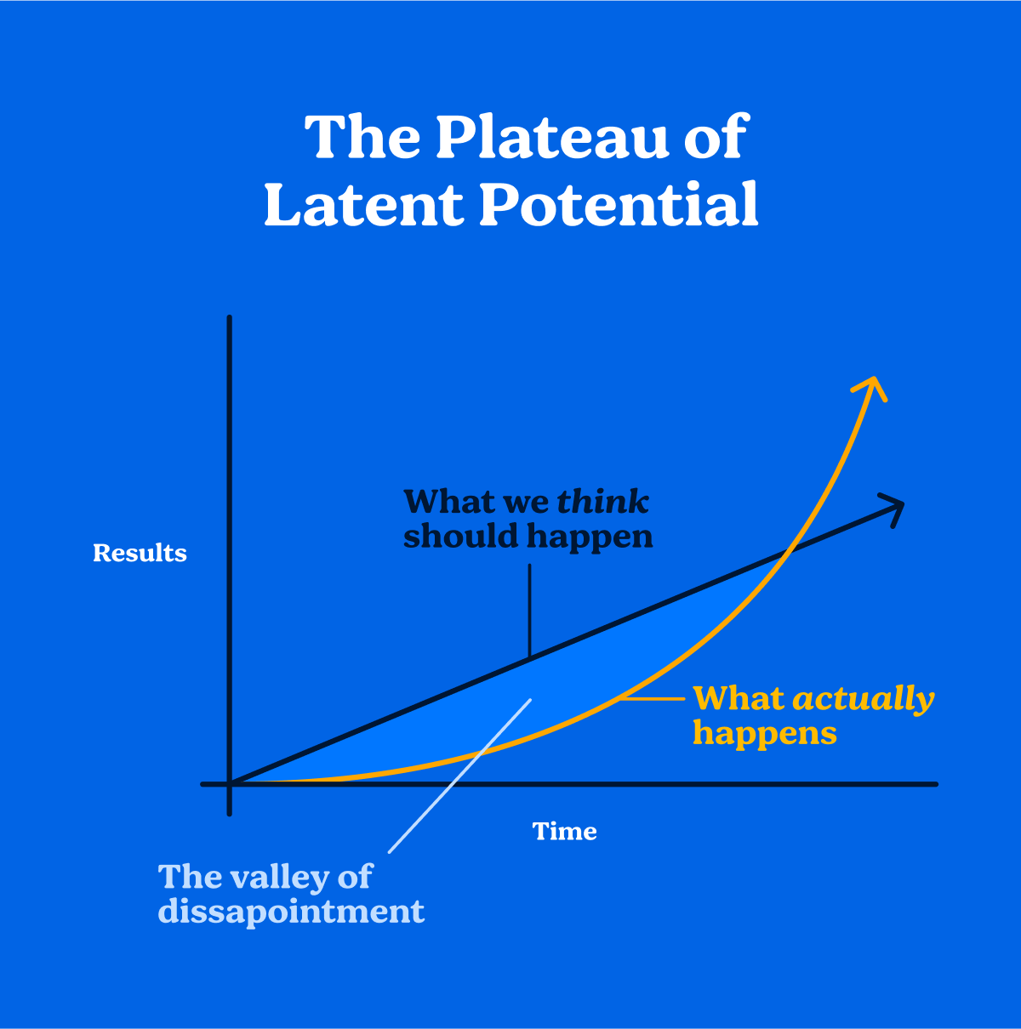

Early progress is slower than we expect

‍

**3. Goals don't work. Use systems.**

‍

Forget goals. Focus on systems.

‍

Classic productivity advice emphasizes goal setting. Companies use Objectives and Key Results (OKRs) and people use New Year's Resolutions. With such a strong focus on goals you'd think we'd all be succeeding, but we all know people who've failed to hit their goals (including ourselves!). What's the difference between someone who succeeds and someone who fails? Hint: it's not their goals.

‍

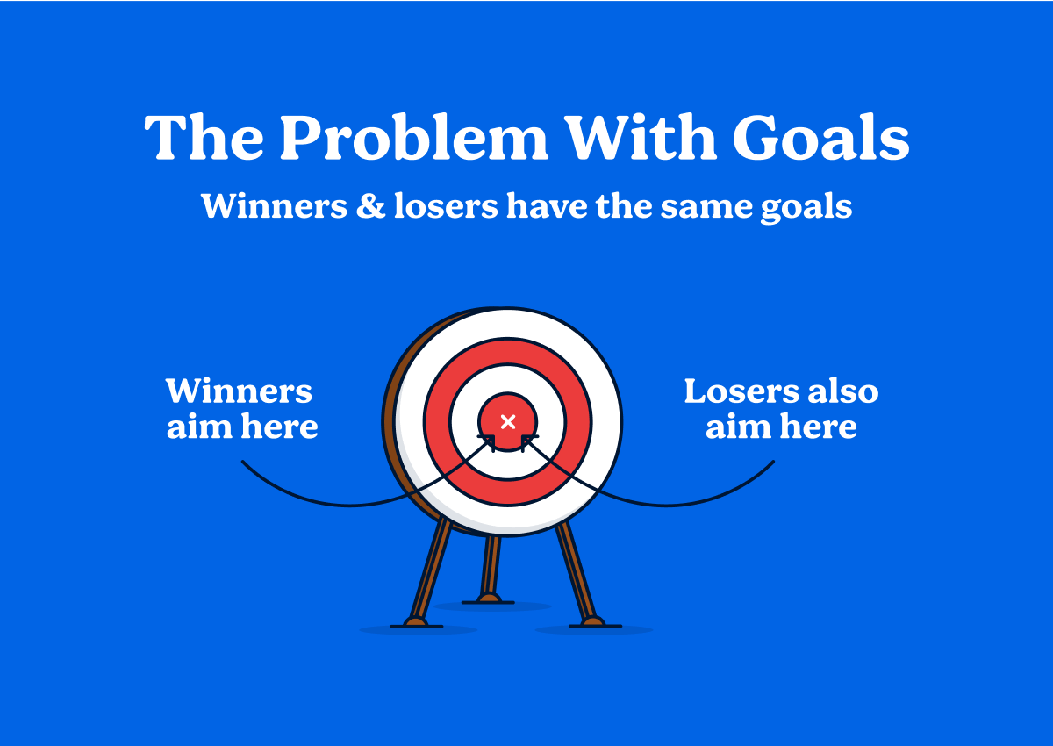

Winners and losers have the same goals

‍

What we really need is something that makes success inevitable.

Imagine two people trying to start a weekly newsletter.

Person A writes down their goal, but they’re overwhelmed and don’t know where to start, so they don’t take action towards achieving it. Person B focuses on the steps to achieve their goal. They create a system:

* Write every morning at 8 AM for 30 minutes
* Edit on Thursdays at 6 PM
* Schedule the email to go out on Monday at 10 AM.

‍

Which person is more likely to start a newsletter?

We don't need better goals. We need better systems.

‍

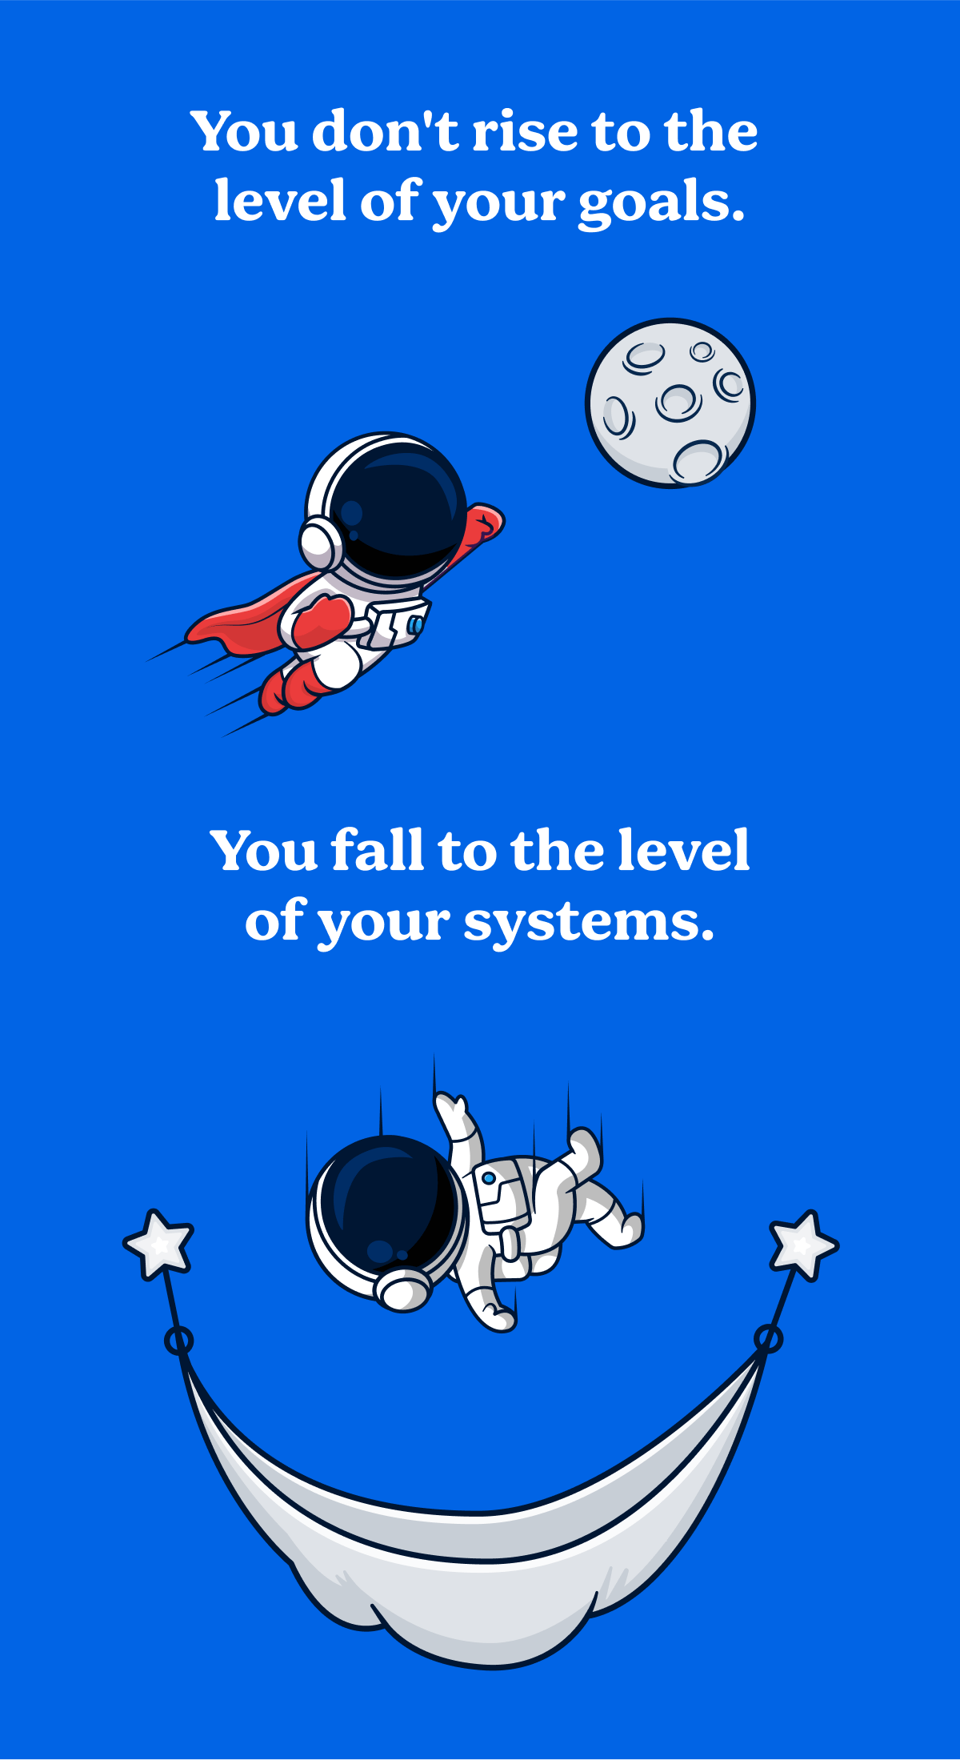

You don't rise to the level of your goals. You fall to the level of your systems.

‍

**4. Lasting change is identity change.**

There are three layers involved in changing any behavior: identity, process, and outcomes.

‍

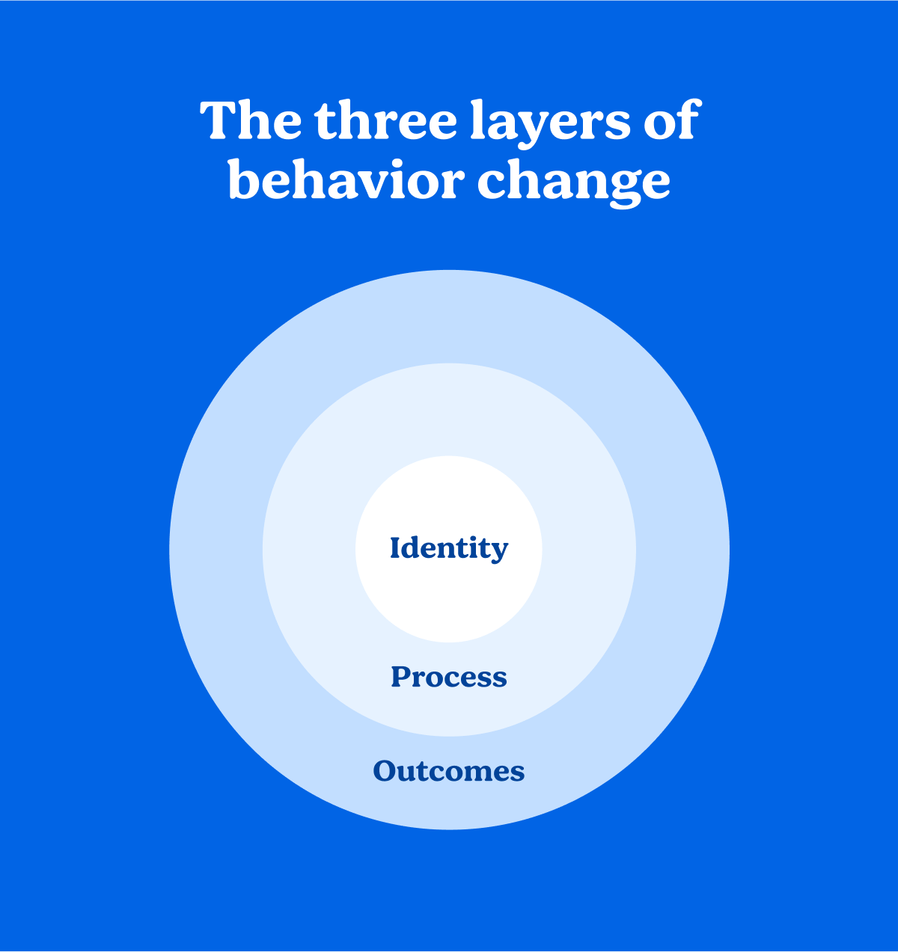

The three layers of behavior change: Identity, Process & Outcomes.

‍

Every single person trying to change thinks about the outcome layer. You know the outcome you want to achieve. For example:

* Lose 10lbs
* Stop drinking
* Write a novel

‍

This is the ***what*** of behavior change. Most attempts to change start here.

People who start to achieve their goals work on the middle layer—process. They set up a time to go to the gym and plan a new workout routine for when they get there.

Very few people consider the third layer—Identity. This layer involves changing your beliefs about yourself and the world.

As a result, most people try to change habits from the outside in. They focus on what they want without changing their beliefs. Even if they succeed, beliefs from their old identity prevent them from making a lasting change.

If you want to make changes that last don't start with ***what*** ***you want***. They start with ***who*** ***you want to become***. Start your habit change by changing your identity.

‍

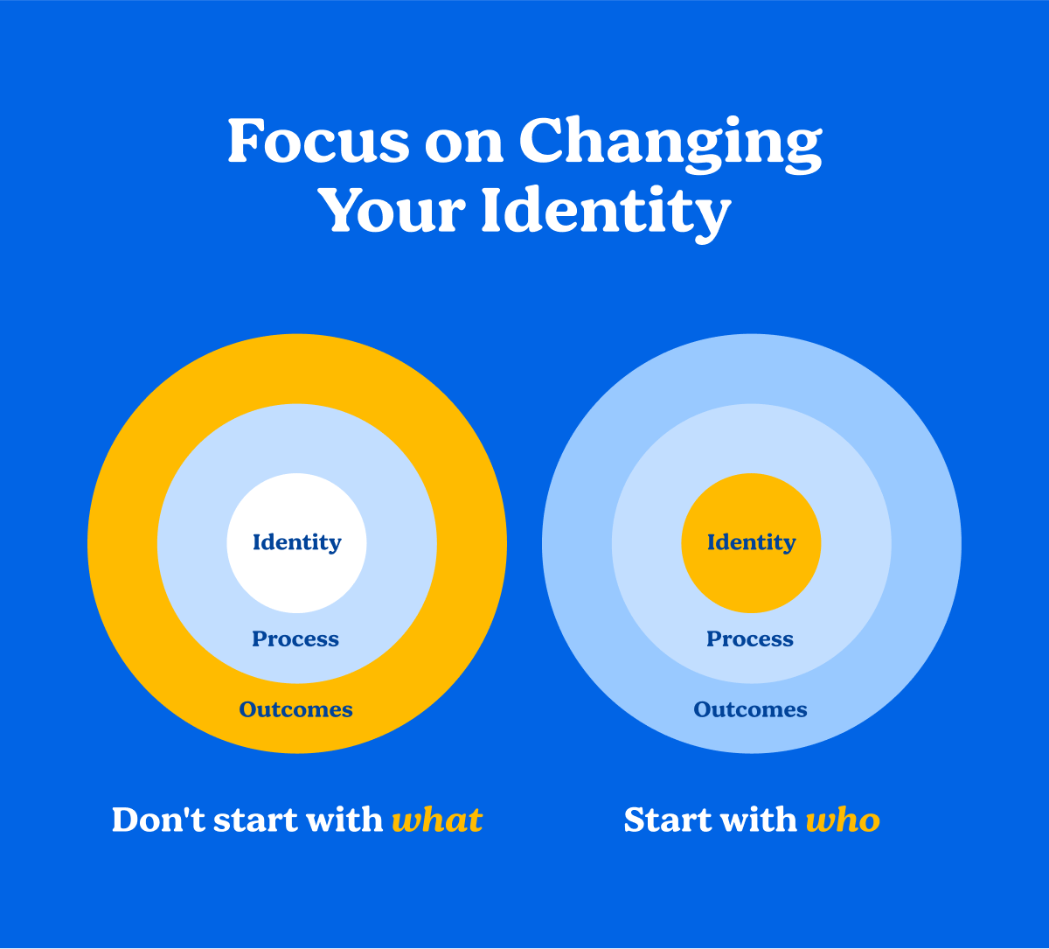

Start by changing your identity.

‍

Most of us have self talk that sabotages us. You might too. It's hard to make lasting change if your internal voice is telling you you're not good enough. Making changes that last starts by shifting these limiting beliefs.

‍

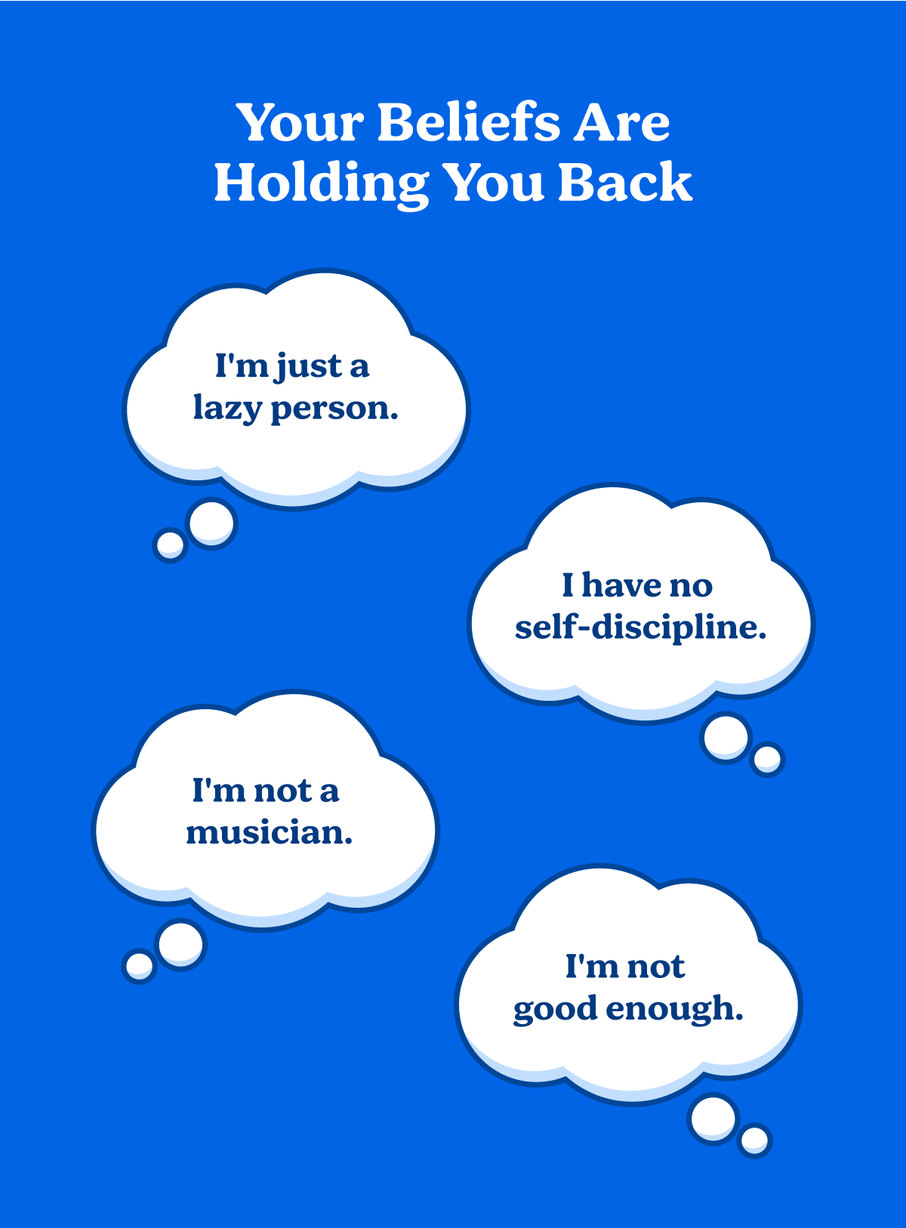

Your beliefs are holding you back

‍

If making positive change feels like a struggle, your identity may be blocking you.

‍

Your identity is blocking you

‍

If identity change is so important, what can you do about it? There are two steps:

1. Decide who you want to be
2. Prove it to yourself with small wins

‍

You can think of every habit and every action as a vote for the person you want to be. Every time you exercise it’s a vote you’re a healthy person.

‍

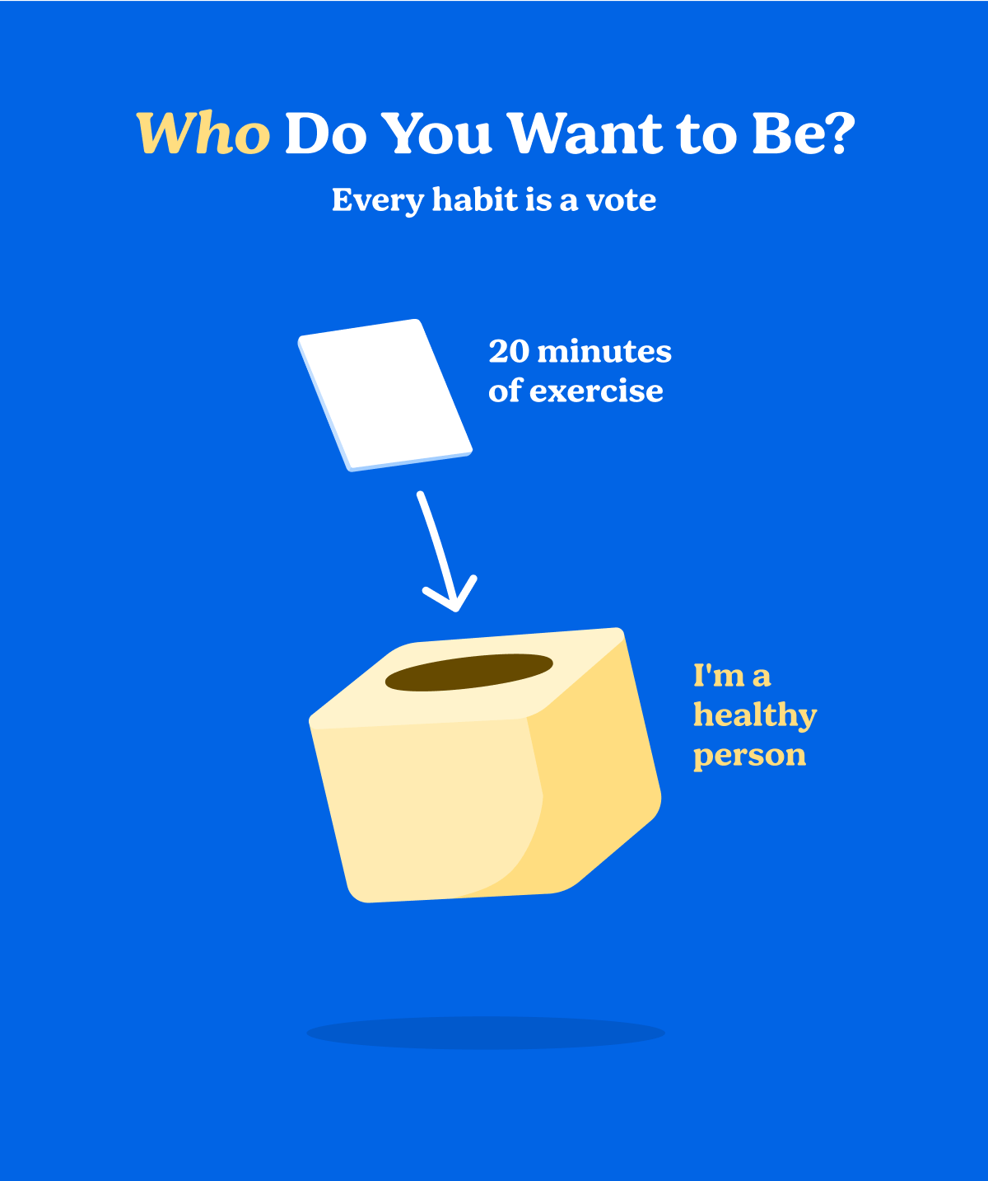

Who do you want to be?

‍

When you practice these habits over and over your votes accumulate. This proof starts to shift your identity.

‍

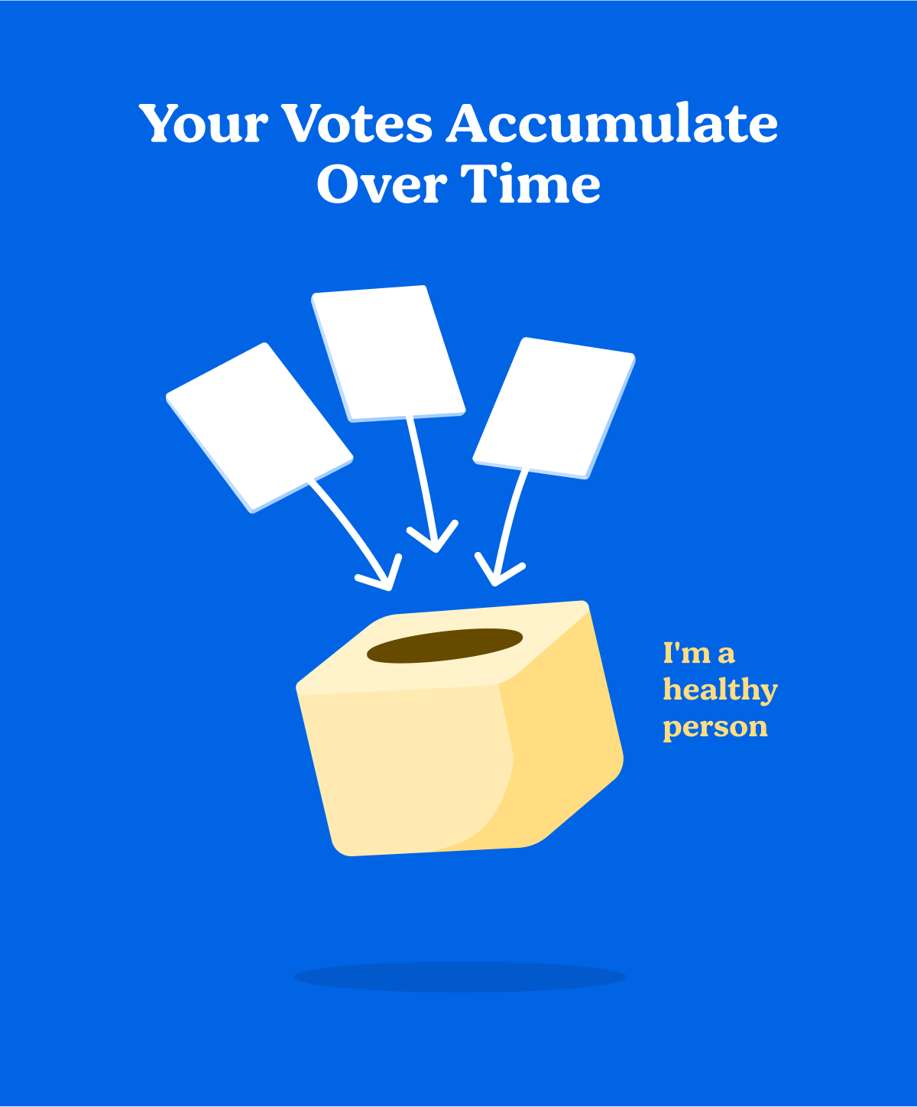

Each tiny vote proves you are who you want to be

‍

The best part is that you don’t have to be perfect. You just need the majority of the votes.

‍

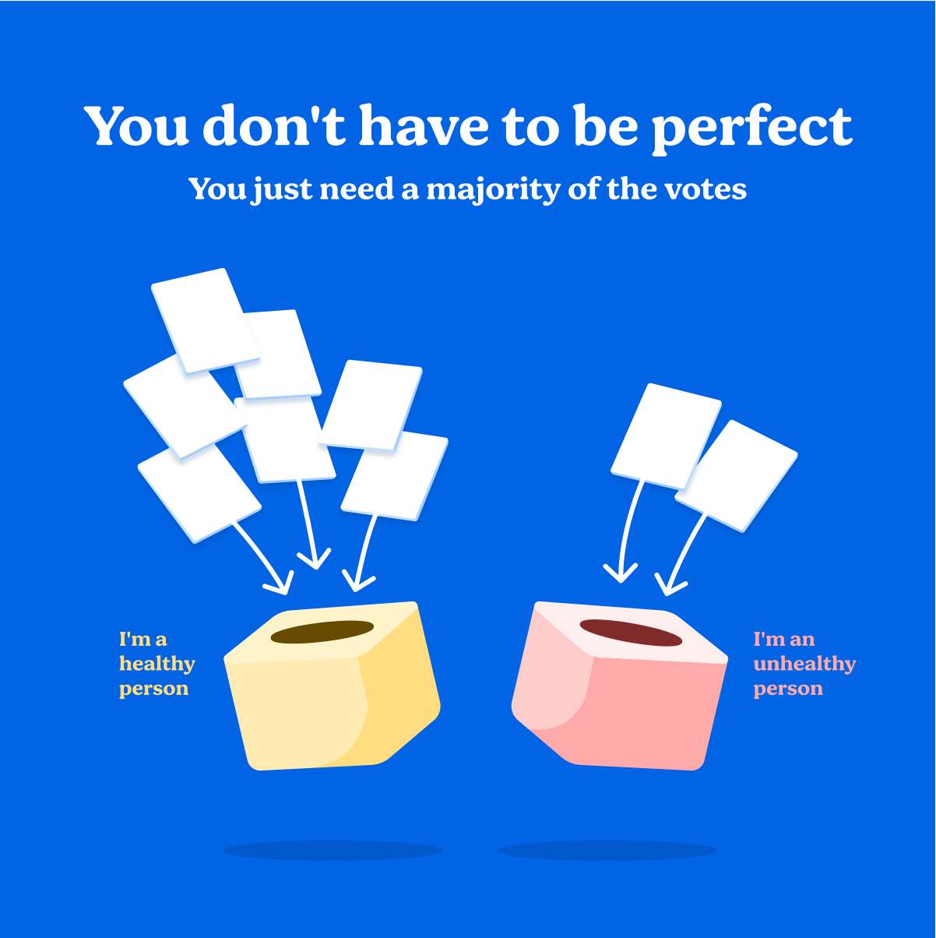

You don't have to be perfect

‍

This is the power of habits. Stick with them long enough and you can actually change your identity.

‍

**5. How to build good habits and break bad ones**

Ok great, we know we need to repeat tiny habits. But how do you get yourself to take action so you can become who you want to be? The key is to understand what drives your daily habits—The Habit Loop:

‍

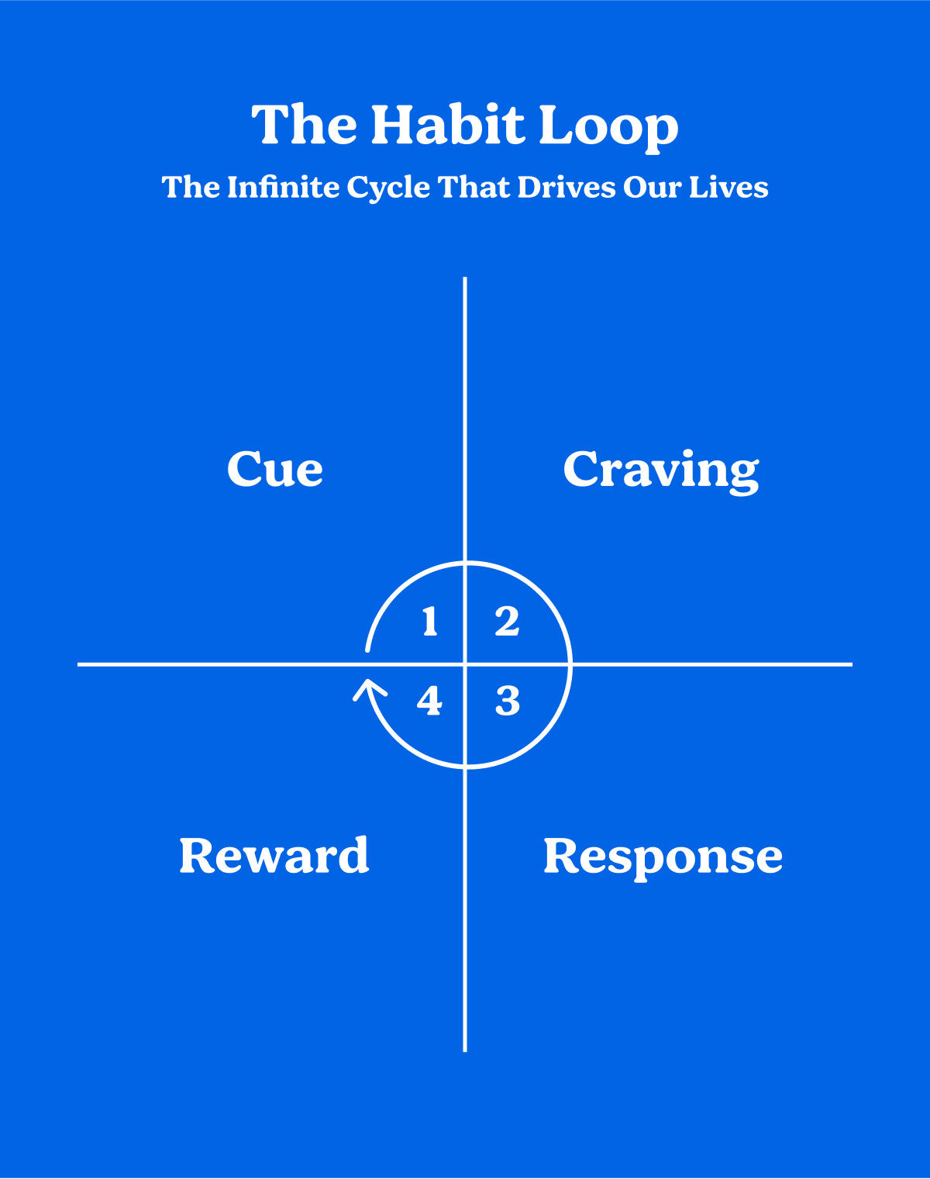

The Habit Loop

‍

This 4 step process is beneath everything you do.

1. A **cue** triggers a craving
2. The **craving** makes you want a reward
3. You **respond** to get that reward
4. The **reward** satisfies your craving

‍

Understanding these 4 steps gives you a blueprint for building good habits and breaking a bad ones. If you want to build a good habit you can:

1. Make it Obvious (cue)
2. Make it Attractive (craving)
3. Make it Easy (response)
4. Make it Satisfying (reward)

‍

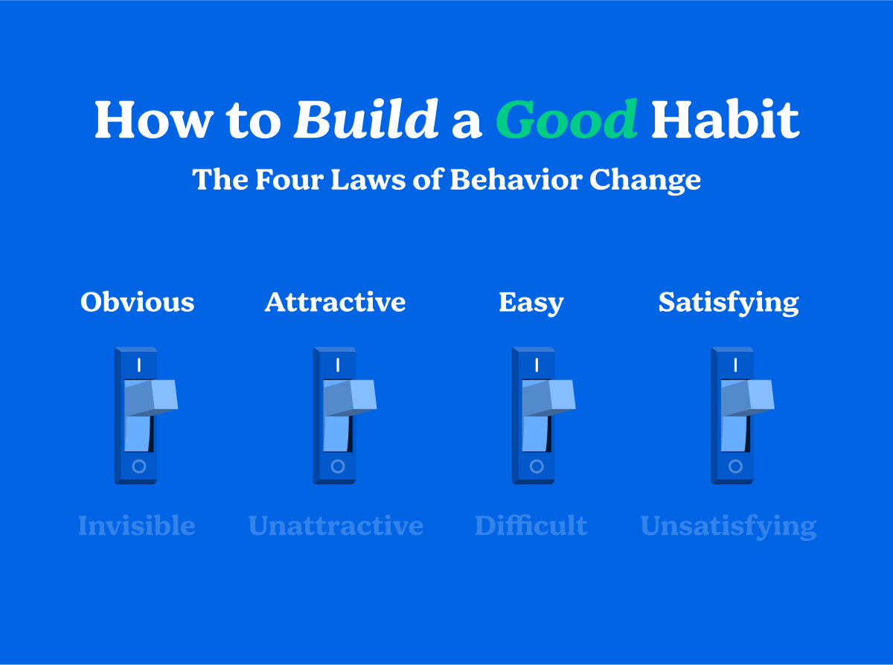

How to build a good habit

‍

You can make good habits **obvious** by:

* Creating visual cues in your environment that prompt you to act
* Setting implementation intentions—"I will [BEHAVIOR] at [TIME] in [LOCATION]

You can make good habits **attractive** by

* Temptation bundling—pairing something you *want* to do with something you *need* to do
* Joining social groups where your desired behavior is the norm

You can make good habits **easy** by

* Using the two minute rule—when you start a habit it should take less than 2 minutes to complete
* Focusing on quantity over quality when you're creating something new

You can make good habits **satisfying** by

* Making rewards immediate after you accomplish a good habit
* Using visual progress and habit tracking to make each action more satisfying

‍

If you want to break a bad habit you can:

1. Make it Invisible (cue)
2. Make it Unattractive (craving)
3. Make it Difficult (response)
4. Make it Unsatisfying (reward)

‍

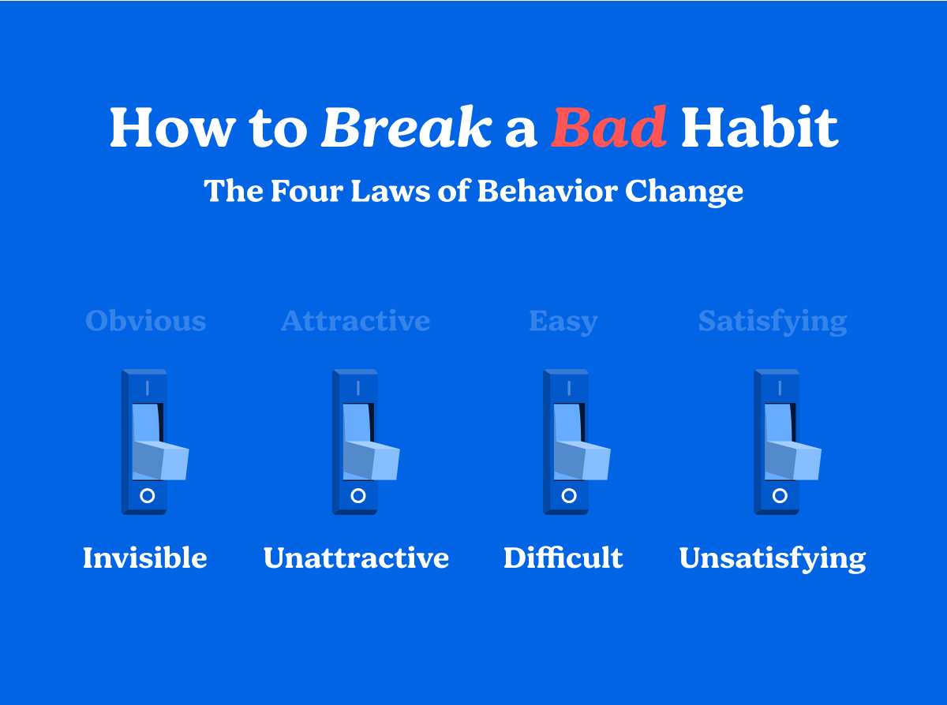

How to break a bad habit

‍

You can make bad habits **invisible** by:

* Reducing visual cues in your environment for the bad habit
* Spending less time in tempting situations

You can make bad habits **unattractive** by:

* Highlighting the benefits of avoiding the bad habit

You can make bad habits **difficult** by:

* Using a commitment device—a one-time choice that locks in your behavior in the future
* Adding friction that makes a bad habit harder to do

You can make bad habits **unsatisfying** by:

* Adding an accountability partner to create an immediate cost to inaction
* Making failure public and painful by letting people watch your behavior

‍

If you're struggling to change your behavior but don’t know why, the answer can be found somewhere in the 4 laws described above.

‍

**4 Practical Tips You Can Use to Create Change**

‍

Let's look at some practical tips you can use to apply these ideas in your life.

‍

**1. Build an environment filled with visual cues**

We all have a deep need to feel in control of our lives. We like to believe we can get what we want by using willpower. This desire blinds us to the most powerful thing we can use to change our habits—our environment. Most of us don't consider changing our environment to make a lasting change in our behavior. As a result, our environment silently changes us.

‍

"Environment is the invisible hand that shapes human behavior"  
*page 82*

‍

The invisible hand of your environment

‍

The strongest cues in your environment come through your primary sense—vision. Seeing a bag of chips on the counter reminds you of their tasty crunch. Seeing your television when you sit on the couch prompts you to put Netflix on. Seeing a notification on your phone nudges you to open Instagram.

‍

"Visual cues are the greatest catalyst of our behavior"  
*page 84*

‍

Adding visual cues to your environment is one of the most powerful and overlooked ways to change your behavior. Here are some examples of environmental changes you could make:

* "I want to feel more calm."
* Put a meditation pillow in your living room.
* "I want to be a musician."
* Get a guitar stand and leave a guitar next to your bed
* "I want to floss more."
* Put a habit tracker on your wall in the bathroom

‍

These environmental changes make your goals more obvious (cue) and easy (response). You can use your environment in the opposite way for our bad habits by making them invisible and difficult.

If you recognize the power of your environment, you can design your home and office to help you hit your goals.

‍

"Be the designer of your world, not merely the consumer of it."  
*page 87*

‍

**2. Focus on quantity over quality**

Jerry Uelsmann taught a photography class at the University of Florida. On the first day of class, he decided to run an experiment.

He divided his students into two groups. The first group was the "quantity" group. Their grade would be based solely on the number of photos they produced. 100 photos would get an A, 90 photos a B, 80 photos a C, etc.

The second group was the "quality" group. Their entire grade would be based on the excellence of one photo. To get an A it would need to be nearly perfect.

At the end of the class the best photos came out of the *quantity* group. These students spent their time running photo tests. They tried different lighting, experimented with lenses, and took photos to test composition.

The *quality* group behaved differently. They read, studied, and speculated about perfection. By the end of the class they had one mediocre photo and a bunch of unverified theories.

‍

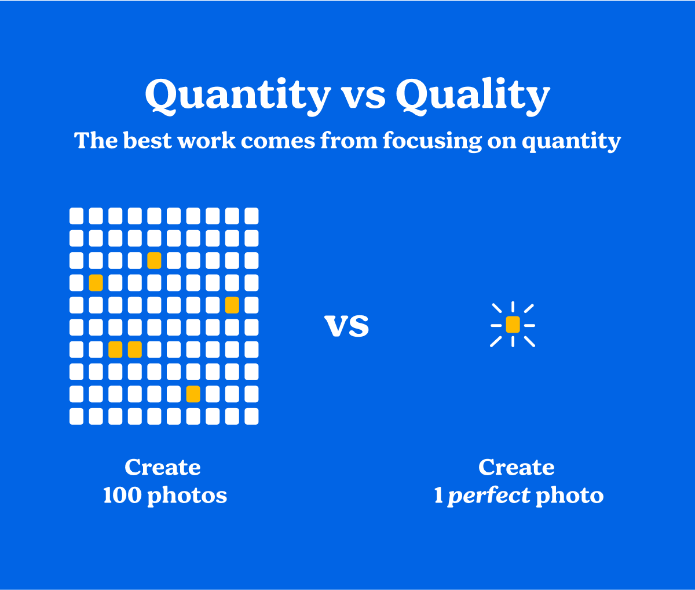

Focusing on quantity leads to better results

‍

If you want to improve, focus on volume and forget about being perfect. By practicing over and over you'll begin to improve. In the large quantity of work you create, excellence will emerge.

**3. Stack your habits**

Stanford professor B.J. Fogg invented the idea of Habit Stacking as a part of his Tiny Habits program. It's a way to use the completion of one task as the cue to begin the next one. Rather than trying to keep track of all our habits individually we can use Habit Stacking to do them one after the other.

It starts by picking a habit you're already repeating and planning one to do next.

‍

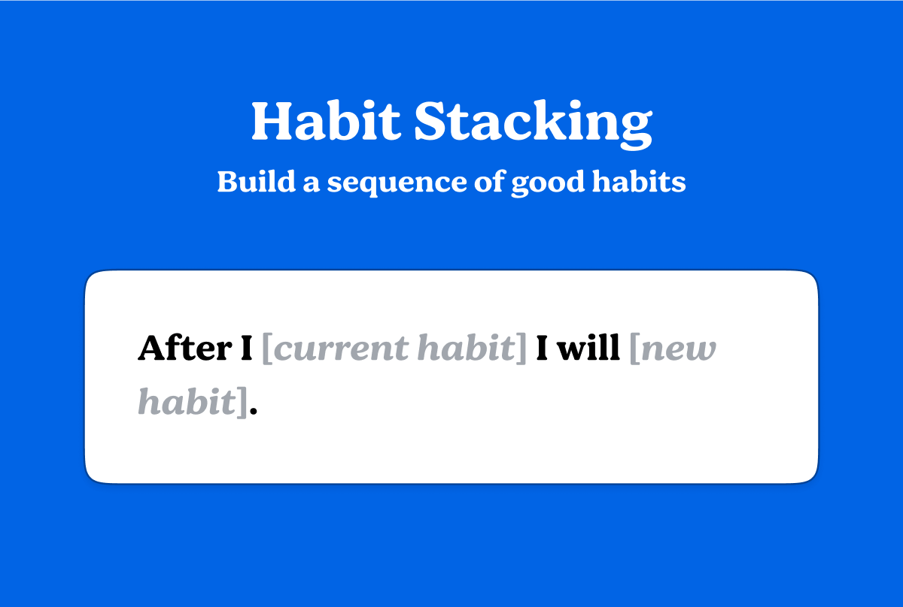

Habit stacks help you chain good habits together

‍

An example might look like this:

* After I wake up I will meditate
* After I meditate I will brush my teeth
* After I brush my teeth I will exercise
* After I exercise I will shower
* After I shower I will journal
* After I journal I will open my to do list

‍

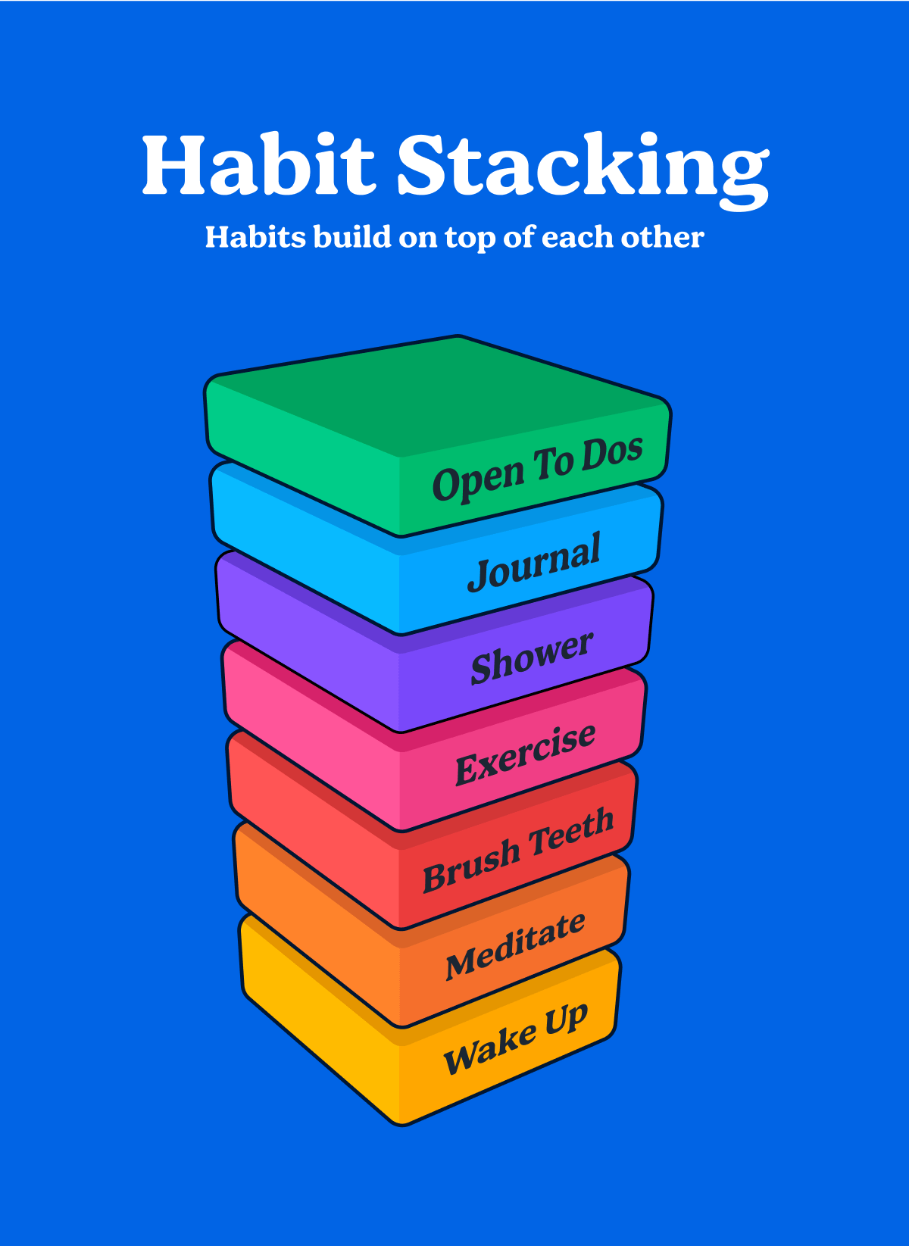

An example of a morning routine habit stack

‍

Building your habits on top of one another can help you build powerful routines. Rather than needing a cue for each behavior you use finishing one to cue the next. These large stacks of habits lead to massive change.

‍

**4. Habit tracking**

Habit tracking helps you facilitate change because it leverages 3 of The Four Laws of Behavior Change:

* Make it Obvious (cue)
* Make it Attractive (craving)
* Make it Satisfying (reward)

‍

Habit tracking makes your habits **more obvious** by giving you a visual cue that reminds you to perform a habit. You can multiply this effect by putting your habit tracker in the place in your environment where you perform the habit.

Habit tracking makes your habits **more attractive** by giving you a visual marker of your progress. The results of early progress are invisible, but a habit tracker turns that invisible progress into something you can see.

Habit tracking also makes your habits **more satisfying** by delivering the joy of checking off an item. It's an immediate pleasure you can get long before you start to see the results of your efforts.

‍

**6 Ways I'm Personally Implementing What I Learned From the Book**

‍

**1. Habit Tracking Sheets: Making it Obvious**

It may surprise you that the CEO of a digital note taking app uses an analog method to track his monthly habits. I do eventually make my tracking digital, but all my habit tracking starts on printed habit tracking sheets.

Printed habit sheets have one huge advantage over digital tools—I can put them where I'll see them. I put mine next to my mirror in the bathroom where I know I'll see them first thing in the morning.

‍

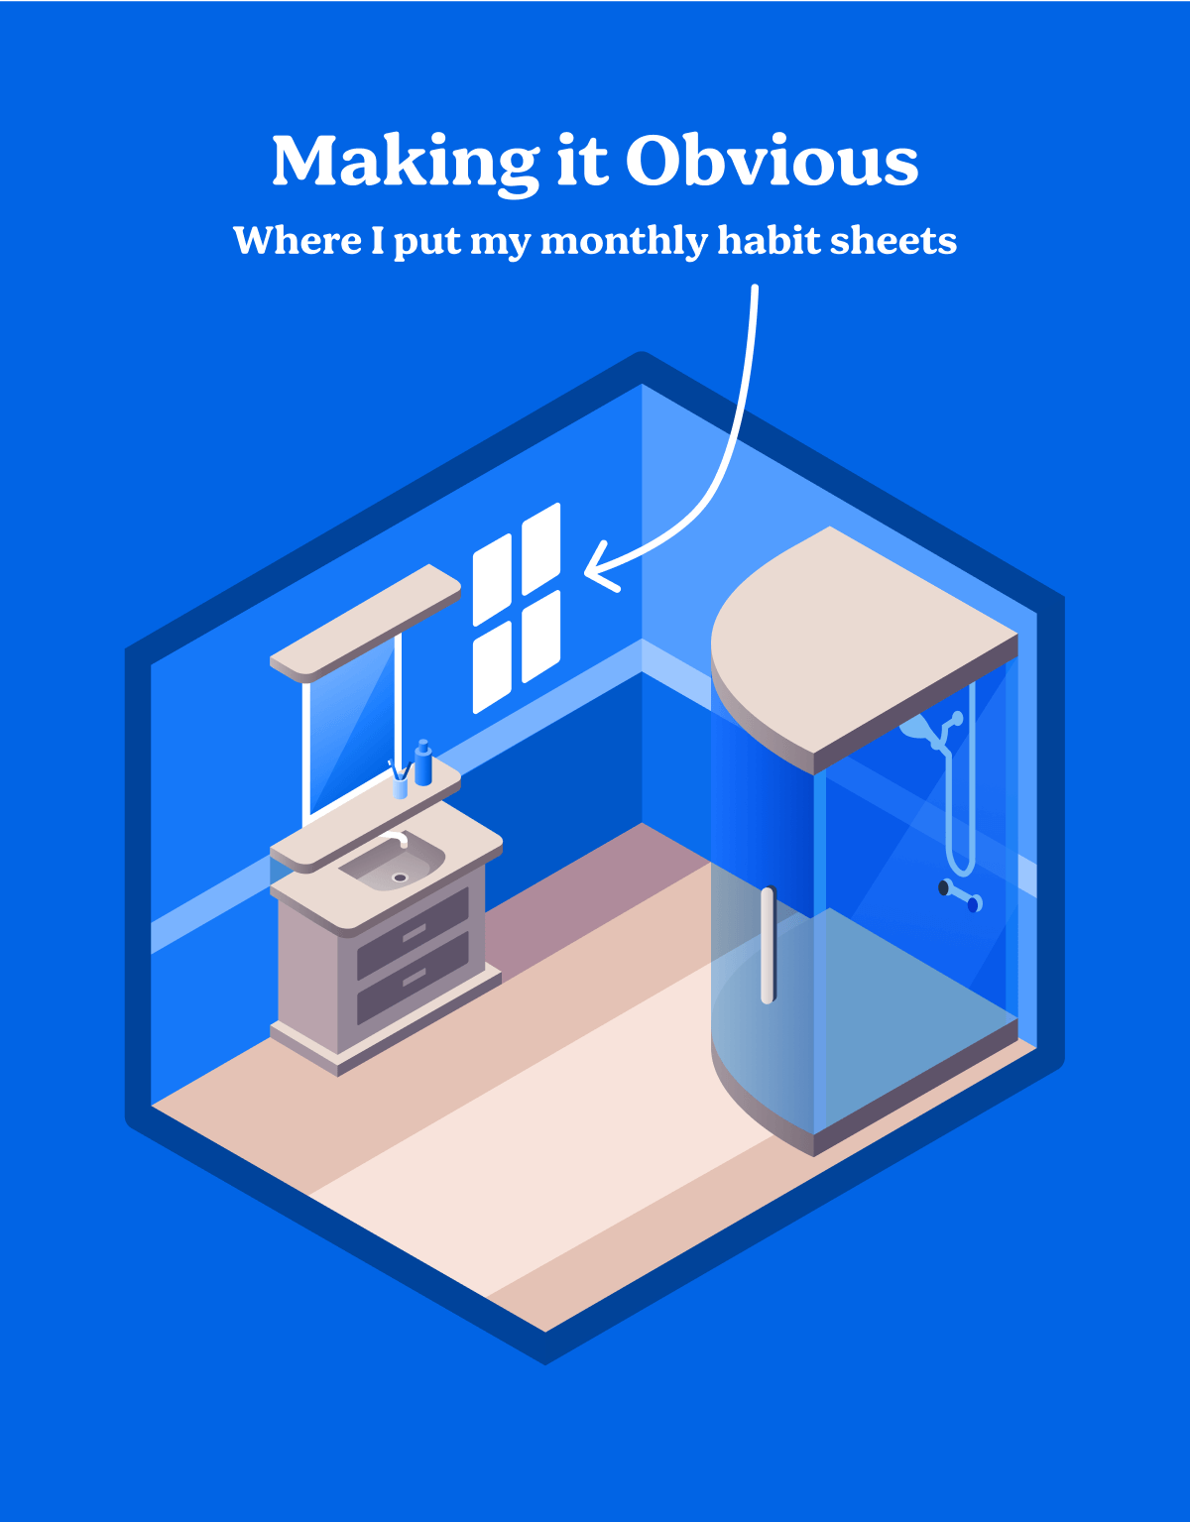

I put my habit sheets where I see them every morning—next to my bathroom mirror

‍

The habit sheets I use are printed on standard 8.5" x 11" paper. When I first started doing these I'd print new sheets every month. But, I don’t own a printer so I stopped doing them several times because of the friction of printing. Now I have them printed on dry erase paper so I can reuse the same sheets over and over again. I check off each day using a wet erase marker so I don't accidentally erase my progress.

I use a separate sheet for each habit so I get the satisfaction of checking off a big box for each habit. This also allows me to add and remove habit tracking sheets as my priorities change.

Each habit sheet consists of:

* A large satisfying visual
* 31 checkboxes

‍

What my daily habit sheets look like

‍

I try to find a visual that motivates me. The purpose of the visual is to remind me why I started doing this habit in the first place. The example above is meant to remind me of how good it feels to work and live in an organized space. I check off this habit for any action that has to do with keeping my space organized:

* Doing laundry
* Cleaning dishes
* Taking out the trash
* Cleaning and organizing my desk space

‍

I don't have an exact rule, but I'd estimate I try to do at least 10 minutes of organizing each day to earn a check mark. It's often more, but keeping the requirement low helps me stick to the habit. This is my wife's favorite habit. :)

My current sheets are:

* Loving Kindness—hand on my heart, take a deep breath, and say "Good morning Andrew, I love you."
* Peace of Mind—20 minutes of morning meditation
* Fitness—10+ minutes of exercise
* Organization—10+ minutes organizing my home/workspace
* Take the Initiative—reach out to a friend and suggest something social
* Voice—share something interesting or useful (usually a tweet)
* Healthy Gums—floss before bed

‍

Here's what they look like:

These are the habits I'm currently focused on

‍

I am far from perfect on hitting all these habits. It used to really bother me when I'd miss even a single day. There's a trick I've been using to stay motivated when I miss days.

‍

**2. Staying Motivated When I Miss**

I recently started drawing a heart on days that I miss. It's a reminder to love myself even on the days when I don't get my habits done. This was my wife's idea and it's genius.

I used to look at a 31 day goal sheet with 1-2 missed days and see failure. This seems insane in retrospect, but I think it's pretty common. If you're still reading this blog post you are probably a bit of a perfectionist like me. I encourage you to try this technique and give yourself forgiveness on days that you miss.

It feels good to put something kind on those missed days, and it keeps me paying attention to the sheets. This December I missed a ton of days between Christmas and New Years while traveling to see family. I was able to see some habit sheets that were ~40% hearts and still consider them a win.

‍

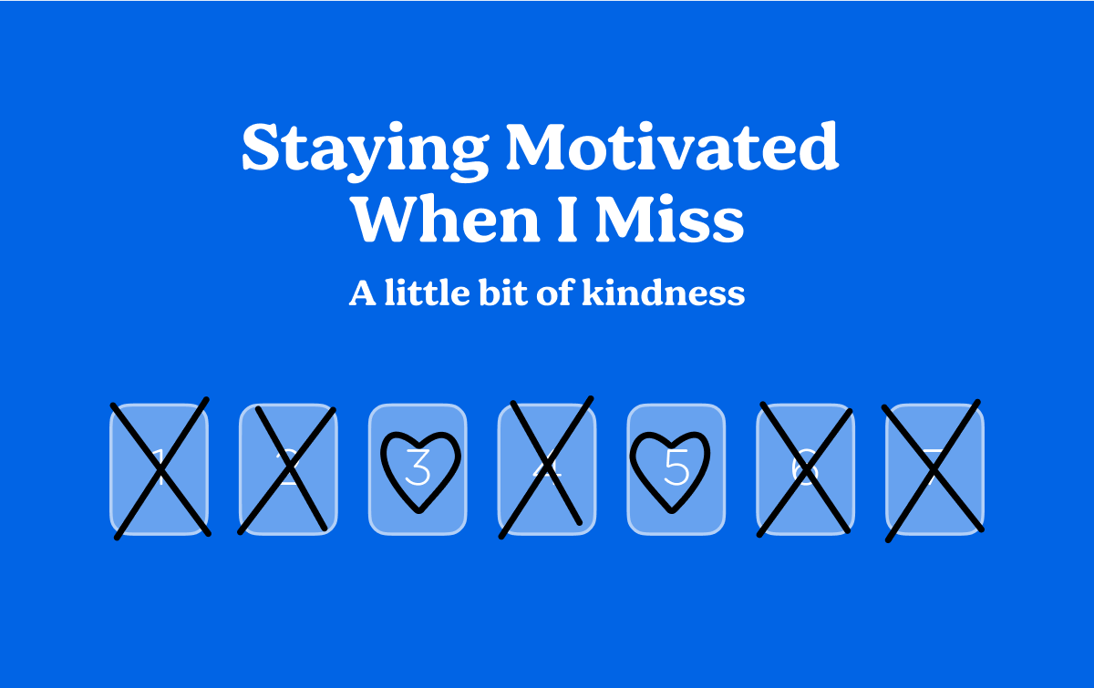

I draw a heart on the days that I miss

‍

**3. Making It Satisfying—Celebrating Each Checkmark**

Every time I check off a habit I do a little physical celebration. It could be looking at myself in the and saying "hell yeah," or just doing a fist pump.

It sounds silly, and that's good. Sometimes I laugh out loud at how ridiculous this is when I do it. This little physical celebration makes it feel even better to check something off. It gives me a fun, immediate reward that keeps me coming back to check off items again.

‍

**4. Habit Stacking in the Morning**

I try to check off as many of my habit sheets as I can first thing in the morning by stacking my habits. My ideal morning habit stack looks like this:

* After I wake up I will stand in front of the mirror, put my hand on my heart, and say "Good morning Andrew, I love you."
* After I give myself a little love I will meditate for 20 minutes
* After I meditate I will go downstairs and exercise
* After I exercise I will come upstairs and shower
* After I shower I will spend a little time organizing the house
* After I organize the house I will go get a morning coffee
* After I get coffee I will sit down with my laptop and open my To Do list in [Thunk Notes](https://www.thunknotes.com/)

‍

There are a couple of things on this list that I do on purpose:

1. My very first habit is very easy and it takes less than 30 seconds
2. I try to do meditation early because it's a habit I have a much harder time fitting in later in the day

‍



I use habit stacking in the morning to get some early wins

‍

**5. Audience Building—Focusing on Quantity and the Long Term**

One big change I'm trying to make after reading the book is focusing on quantity over quality. My natural tendency is to work on something until I think it's as good as I can make it. It's a tendency that's directly at odds with the ideas from the book.

One of my goals this year is to grow the audience for [Thunk Notes](https://www.thunknotes.com/). There are two big changes I'm trying to make to increase my odds of hitting that goal:

1. Focus on quantity over quality
2. Focus on long-term over short term

‍

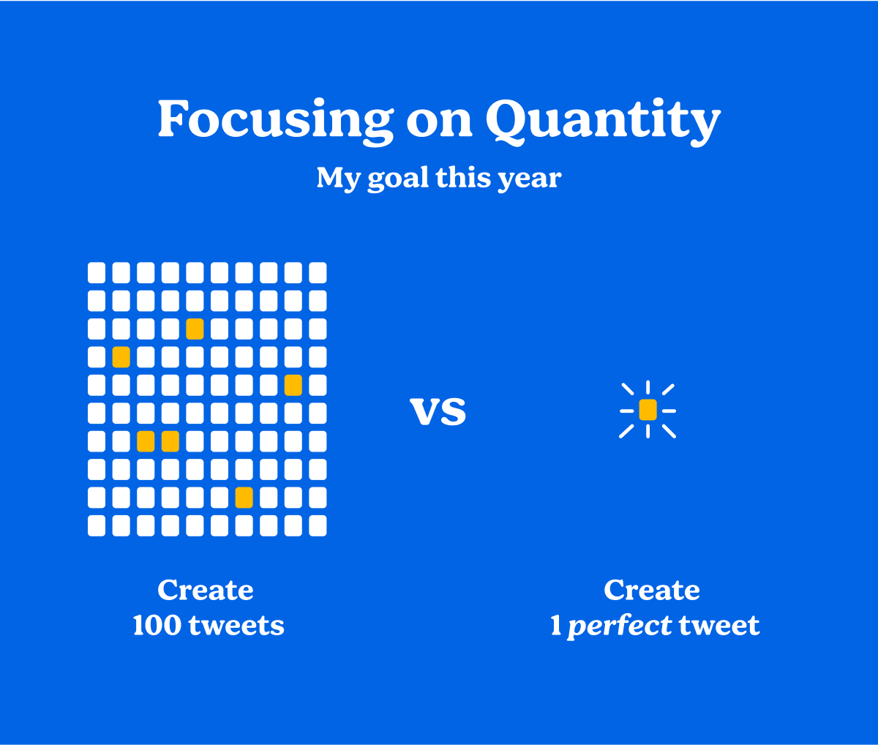

I'm working to emphasize quantity more this year

‍

I'm starting by scheduling tweets to go out every Wednesday for the entire year. Once I'm done I'm going to come back and do Monday, then Thursday. My goal is to see how quickly I can get a full year of tweets scheduled to go out 3 times per week.

‍

**6. Making It Satisfying—Managing My Tasks in Thunk Notes**

To accomplish my Twitter goal, I'm using our to do lists in [Thunk Notes](https://www.thunknotes.com/) to break this down into smaller tasks. Our new to do list helps make progress more visible by showing progress as you check off an item's sub-tasks.

‍

How I'm tracking my goals in Thunk Notes

‍

Thank you for checking out this visual summary. If you found anything useful here, please share this with someone you know who's might benefit. If you have any feedback, [please let me know](https://twitter.com/nalband) on Twitter.

If you've read this whole article, you should definitely check out [my free habit worksheet](https://app.thunknotes.com/GGrAwh8ie6SNShKnqATpgt8AA5C3/The-FREE-Habit-Worksheet). It gives you a set of actionable advice you can use to change your habits.

